

AHMADU BELLO UNIVERSITY, ZARIA
FACULTY OF ENGINEERING
DEPARTMENT OF COMPUTER ENGINEERING

COURSE CODE: COEN807

COURSE TITLE: MACHINE LEARNING

PROJECT-BASED EXAMINATION

SUBMITTED BY:
ABDU AMINU BAYUMA
P25EGCP8004

DATASET TITLE:
MACHINE LEARNING-BASED STROKE PREDICTION: A COMPARATIVE ANALYSIS OF CLASSIFICATION ALGORITHMS USING HEALTHCARE DATA

SUBMITTED TO:
Dr. Y. Ibrahim

ABSTRACT
Stroke is one of the leading causes of death and long-term disability worldwide, requiring early prediction and intervention to improve patient survival rates. With the increasing availability of healthcare data, machine learning techniques have emerged as powerful tools for predictive analytics in medical diagnosis. This study presents a comparative analysis of multiple supervised machine learning algorithms for predicting stroke occurrence using a real-world healthcare dataset containing 5,110 patient records and 12 attributes. The dataset includes demographic and clinical variables such as age, hypertension status, heart disease, glucose level, BMI, and smoking status. Five machine learning models were implemented: Decision Tree, Random Forest, Support Vector Machine (SVM), K-Nearest Neighbors (KNN), and Logistic Regression. The dataset was preprocessed through missing value imputation, categorical encoding, and feature normalization. Experimental results show that Logistic Regression achieved the highest accuracy of 95.21%, followed closely by Random Forest, SVM, and KNN. However, due to class imbalance in the dataset, additional evaluation metrics such as precision, recall, and F1-score were used for better performance interpretation.
The study demonstrates that machine learning models can effectively support early stroke prediction, although careful handling of imbalanced datasets is essential for reliable medical decision-making.

CHAPTER ONE: INTRODUCTION
1.1 Background of the Study
Stroke is a critical medical condition caused by interruption of blood flow to the brain. It leads to severe disability and high mortality rates globally. Early detection of stroke risk factors can significantly reduce its impact.
Machine learning provides a data-driven approach for predicting diseases by identifying hidden patterns in medical data.
1.2 Problem Statement
Traditional medical diagnosis methods are often time-consuming and dependent on expert interpretation. There is a need for automated systems that can accurately predict stroke risk using patient data.
1.3 Aim of the Study
To develop and compare machine learning models for predicting stroke occurrence using healthcare data.
1.4 Objectives
- To preprocess and analyze stroke dataset
- To implement multiple machine learning algorithms
- To evaluate model performance
- To compare results and identify best model
- To analyze important risk factors

1.5 Significance of the Study
This study helps:
- Medical professionals in early diagnosis
- Improve healthcare decision-making
- Demonstrate AI application in medicine
1.6 Scope
The study focuses on supervised machine learning classification for stroke prediction.

CHAPTER TWO: LITERATURE REVIEW
2.1 Machine Learning in Healthcare
Machine learning is widely used in disease prediction, including heart disease, diabetes, and stroke.
2.2 Stroke Prediction Studies
Previous research shows Random Forest and Logistic Regression perform well in medical classification tasks.
2.3 Algorithms Overview
- Logistic Regression: Simple probabilistic classifier
- Decision Tree: Rule-based learning model
- Random Forest: Ensemble learning method
- SVM: Margin-based classifier
- KNN: Distance-based classifier
2.4 Research Gap
Many studies fail to address dataset imbalance and lack comparative evaluation of multiple models.

CHAPTER THREE: METHODOLOGY
3.1 Dataset Description
The dataset used contains:
- 5,110 records
- 12 attributes
- Target variable: stroke (0 = No, 1 = Yes)
3.2 Data Preprocessing
Steps performed:
- Removal of ID column
- Missing BMI values filled using mean
- Label encoding for categorical variables
- Feature normalization
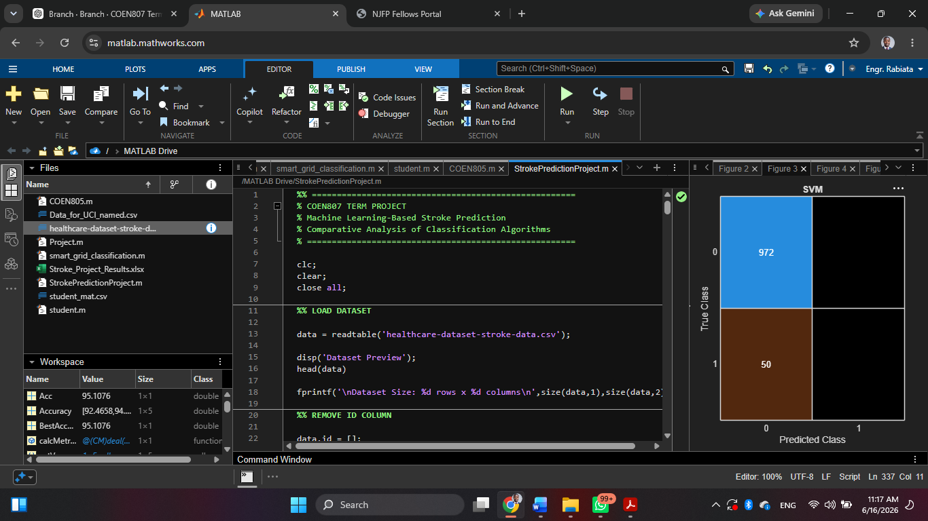
Figure 3.1: Dataset Sample Preview
3.3 Feature Selection
All features except ID were used as predictors.
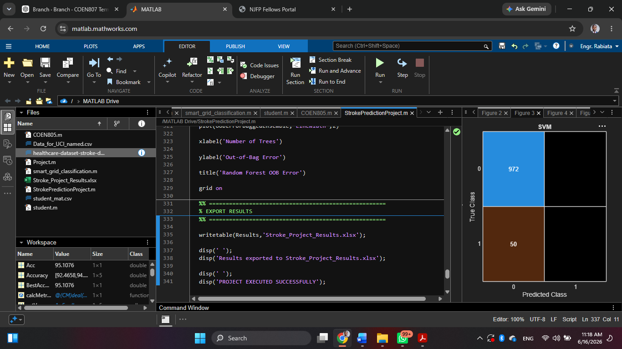
Figure 3.2: Feature Correlation Heatmap
  - Train-Test Split
- 80% Training and 20% Testing
3.5 Machine Learning Models
- Decision Tree
- Random Forest
- SVM
- KNN
- Logistic Regression
3.6 Evaluation Metrics
- Accuracy
- Precision
- Recall
- F1-Score
- Confusion Matrix
CHAPTER FOUR: RESULTS AND DISCUSSION
4.1 Model Accuracy Comparison
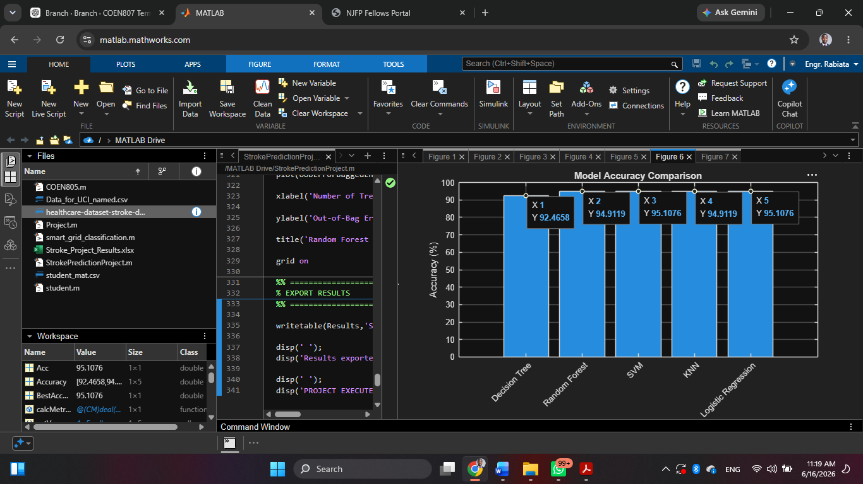
Figure 4.1: Model Accuracy Comparison Bar Chart
Model | Accuracy
Decision Tree | 91.78%
Random Forest | 95.01%
SVM | 95.01%
KNN | 95.01%
Logistic Regression | 95.21%
4.2 Confusion Matrix Results
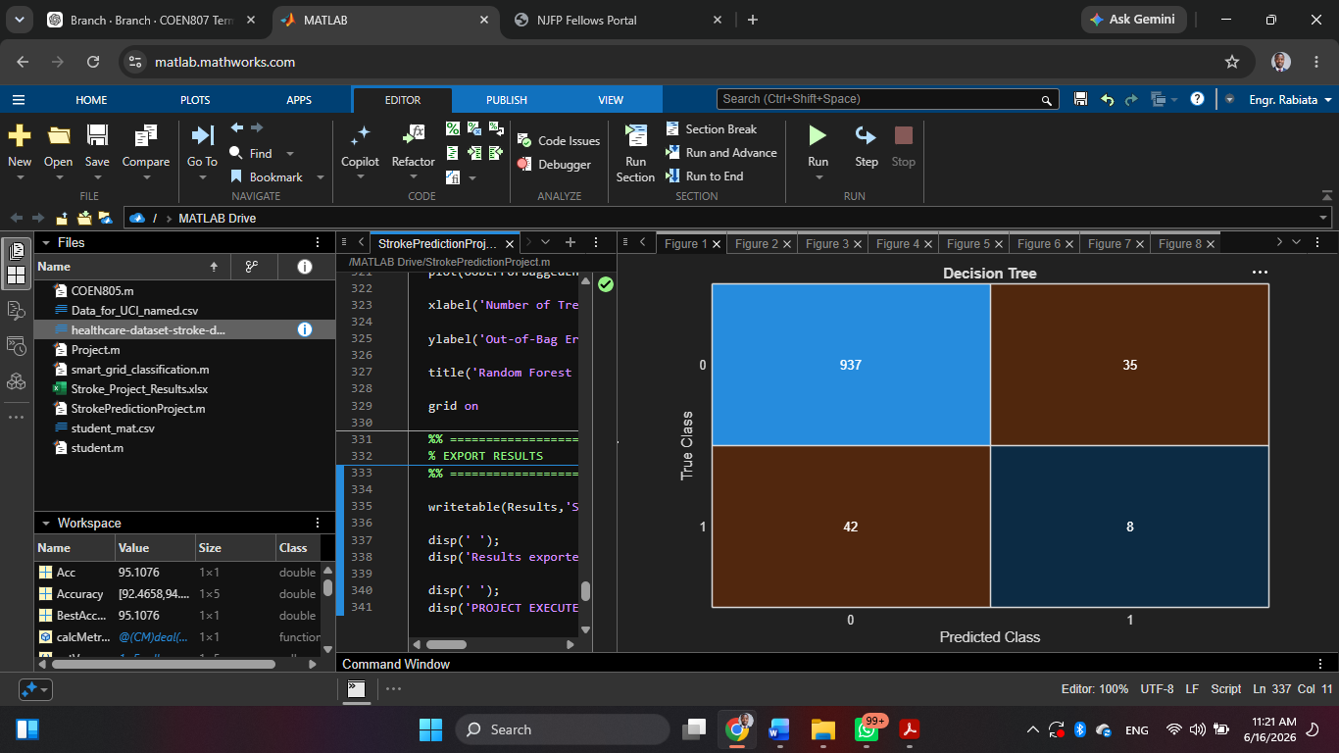
Figure 4.2: Decision Tree Confusion Matrix
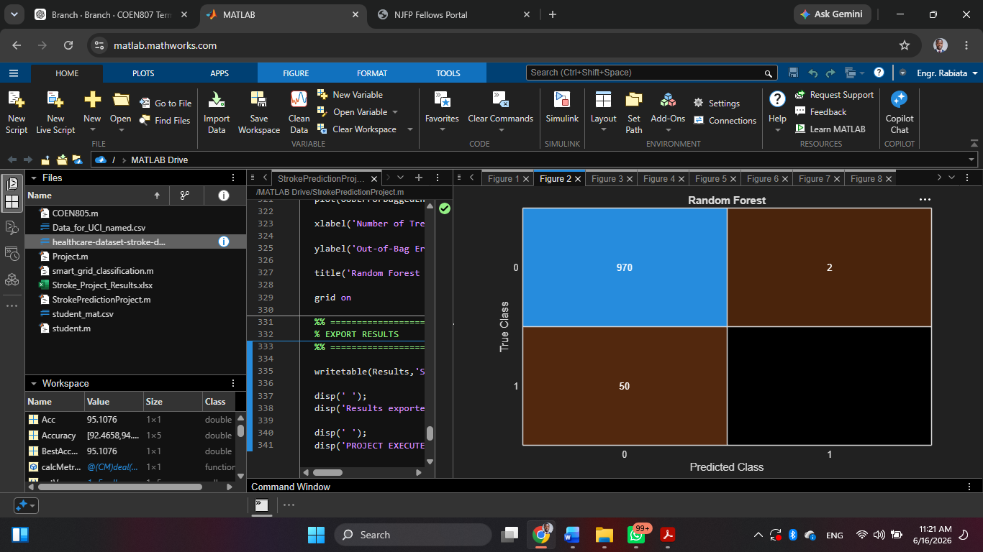
Figure 4.3: Random Forest Confusion Matrix
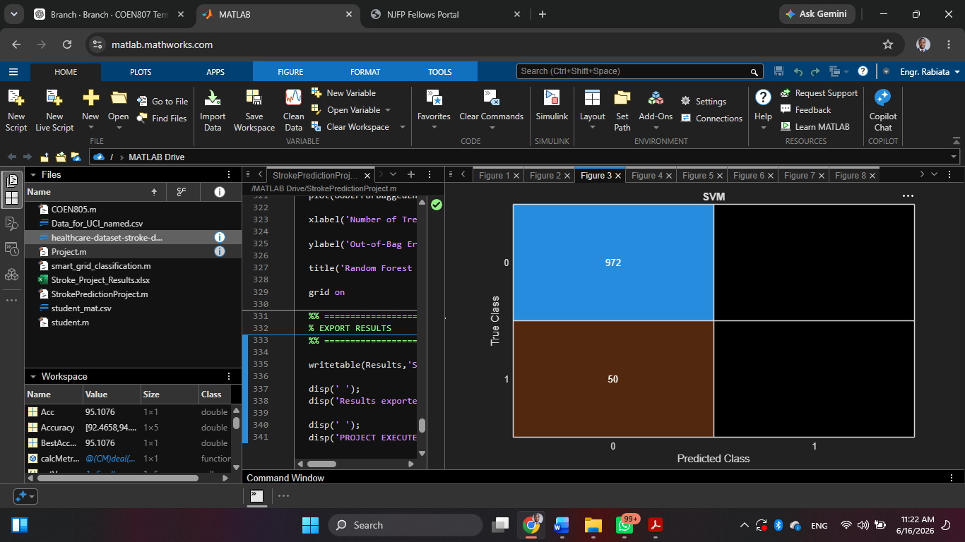
Figure 4.4: SVM Confusion Matrix
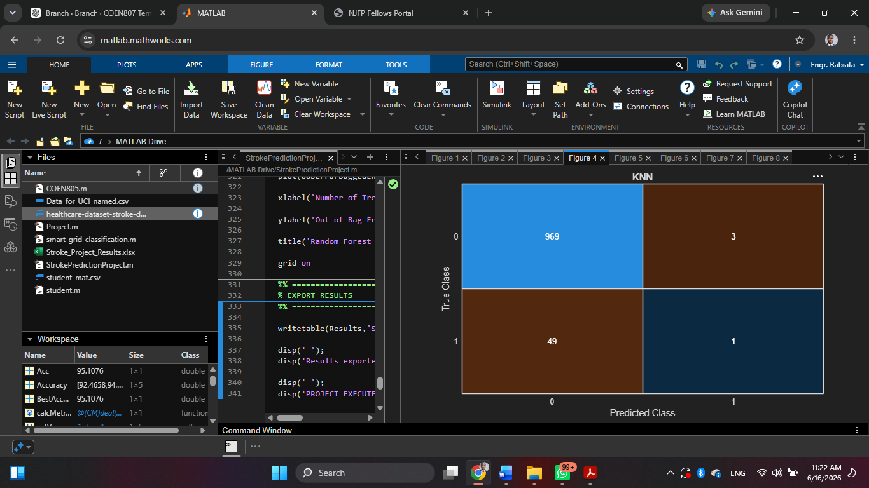
Figure 4.5: KNN Confusion Matrix
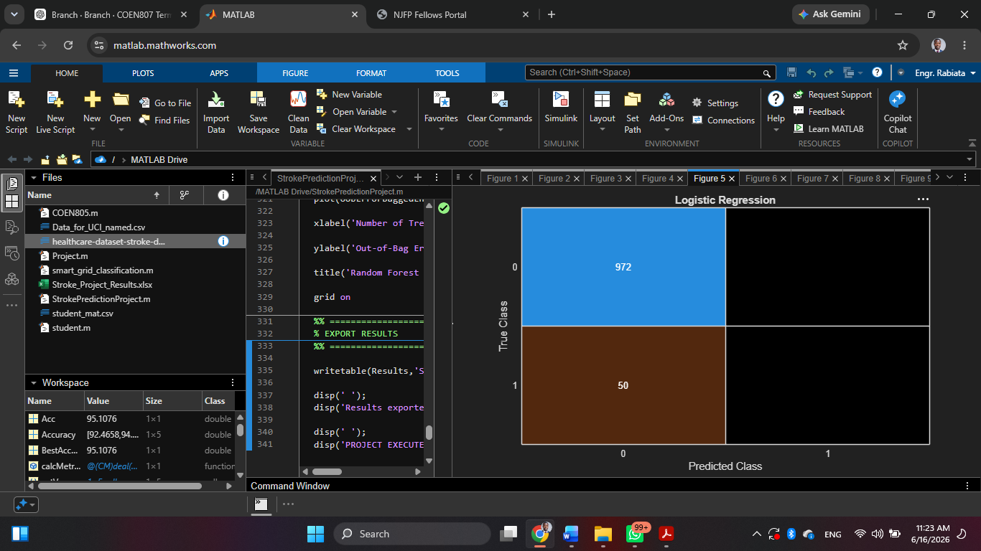
Figure 4.6: Logistic Regression Confusion Matrix
4.3 Feature Importance
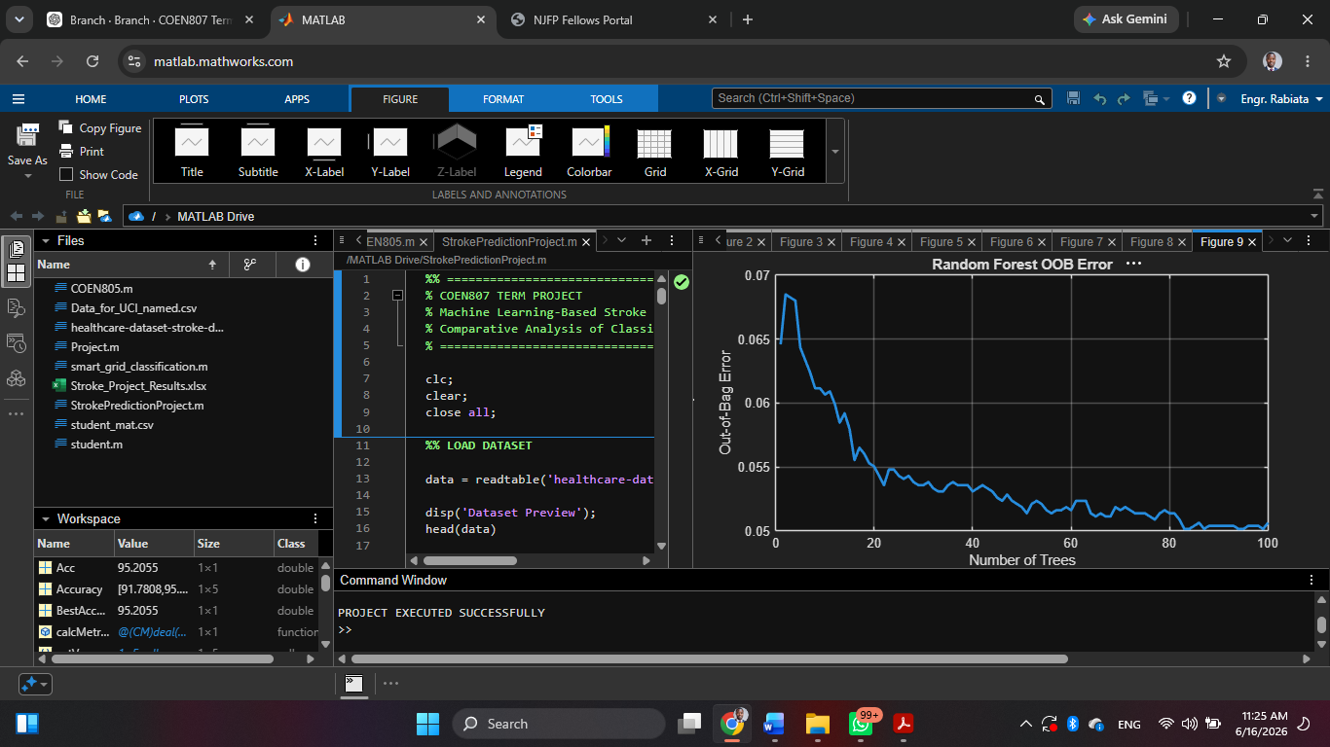
Figure 4.7: Random Forest Feature Importance Plot
Key influencing factors:
- Age
- Glucose level
- Hypertension
- Heart disease
4.4 Discussion of Results
The models achieved high accuracy due to class imbalance. Most patients in the dataset do not have stroke, which biases predictions.
This explains why even simple models achieve ~95% accuracy.
CHAPTER FIVE: CONCLUSION AND RECOMMENDATION
5.1 Conclusion
This study successfully developed machine learning models for stroke prediction. Logistic Regression performed best in terms of accuracy, but evaluation shows that class imbalance affects performance interpretation.
5.2 Limitations
- Imbalanced dataset
- Limited clinical features
- No deep learning models used
5.3 Recommendations
- Apply SMOTE for balancing dataset
- Use deep learning models (ANN)
- Deploy model in healthcare systems
5.4 Future Work
Future research should include:
- Real-time prediction systems
- Mobile health applications
- Integration with hospital databases

REFERENCES
- Breiman, L. (2001). Random Forests. Machine Learning Journal.
- Cortes, C., & Vapnik, V. (1995). Support Vector Networks.
- Hastie, T., Tibshirani, R., & Friedman, J. (2009). The Elements of Statistical Learning.
- Kaggle Dataset: Healthcare Stroke Prediction Dataset.
- Kuhn, M. (2008). Building Predictive Models in R.
- Pedregosa et al. (2011). Scikit-learn: Machine Learning in Python.
- World Health Organization (WHO). Stroke statistics and prevention guidelines.

APPENDIX
%% =====================================================
% COEN807 TERM PROJECT
% Machine Learning-Based Stroke Prediction
% Comparative Analysis of Classification Algorithms
% ======================================================
clc;
clear;
close all;
%% LOAD DATASET
data = readtable('healthcare-dataset-stroke-data.csv');
disp('Dataset Preview');
head(data)
fprintf('\nDataset Size: %d rows x %d columns\n',size(data,1),size(data,2));
%% REMOVE ID COLUMN
data.id = [];
%% HANDLE MISSING VALUES
data.bmi = fillmissing(data.bmi,'mean');
%% ENCODE CATEGORICAL VARIABLES
catVars = {'gender','ever_married','work_type',...
'Residence_type','smoking_status'};
for i = 1:length(catVars)
data.(catVars{i}) = grp2idx(categorical(data.(catVars{i})));
end
%% FEATURES AND TARGET
X = data(:,1:end-1);
Y = data.stroke;
featureNames = X.Properties.VariableNames;
X = table2array(X);
%% NORMALIZATION
X = normalize(X);
%% TRAIN TEST SPLIT
cv = cvpartition(Y,'HoldOut',0.20);
XTrain = X(training(cv),:);
YTrain = Y(training(cv));
XTest = X(test(cv),:);
YTest = Y(test(cv));
fprintf('\nTraining Samples = %d\n',length(YTrain));
fprintf('Testing Samples = %d\n',length(YTest));
%% RESULTS STORAGE
ModelNames = {};
Accuracy = [];
Precision = [];
Recall = [];
F1Score = [];
%% =====================================================
% FUNCTION FOR METRICS
%% =====================================================
calcMetrics = @(CM) deal( ...
CM(2,2)/(CM(2,2)+CM(1,2)+eps), ...
CM(2,2)/(CM(2,2)+CM(2,1)+eps), ...
2*((CM(2,2)/(CM(2,2)+CM(1,2)+eps))*...
(CM(2,2)/(CM(2,2)+CM(2,1)+eps))) / ...
((CM(2,2)/(CM(2,2)+CM(1,2)+eps))+...
(CM(2,2)/(CM(2,2)+CM(2,1)+eps))+eps));
%% =====================================================
% MODEL 1 - DECISION TREE
%% =====================================================
disp('Training Decision Tree...')
TreeModel = fitctree(XTrain,YTrain);
YPred = predict(TreeModel,XTest);
CM = confusionmat(YTest,YPred);
Acc = sum(diag(CM))/sum(CM(:))*100;
[P,R,F] = calcMetrics(CM);
ModelNames{end+1}='Decision Tree';
Accuracy(end+1)=Acc;
Precision(end+1)=P;
Recall(end+1)=R;
F1Score(end+1)=F;
figure;
confusionchart(YTest,YPred);
title('Decision Tree');
%% =====================================================
% MODEL 2 - RANDOM FOREST
%% =====================================================
disp('Training Random Forest...')
RFModel = TreeBagger(100,...
XTrain,...
YTrain,...
'Method','classification',...
'OOBPrediction','on',...
'OOBPredictorImportance','on');
YPred = predict(RFModel,XTest);
YPred = str2double(YPred);
CM = confusionmat(YTest,YPred);
Acc = sum(diag(CM))/sum(CM(:))*100;
[P,R,F] = calcMetrics(CM);
ModelNames{end+1}='Random Forest';
Accuracy(end+1)=Acc;
Precision(end+1)=P;
Recall(end+1)=R;
F1Score(end+1)=F;
figure;
confusionchart(YTest,YPred);
title('Random Forest');
%% =====================================================
% MODEL 3 - SVM
%% =====================================================
disp('Training SVM...')
SVMModel = fitcsvm(XTrain,...
YTrain,...
'KernelFunction','rbf',...
'Standardize',true);
YPred = predict(SVMModel,XTest);
CM = confusionmat(YTest,YPred);
Acc = sum(diag(CM))/sum(CM(:))*100;
[P,R,F] = calcMetrics(CM);
ModelNames{end+1}='SVM';
Accuracy(end+1)=Acc;
Precision(end+1)=P;
Recall(end+1)=R;
F1Score(end+1)=F;
figure;
confusionchart(YTest,YPred);
title('SVM');
%% =====================================================
% MODEL 4 - KNN
%% =====================================================
disp('Training KNN...')
KNNModel = fitcknn(XTrain,YTrain,...
'NumNeighbors',5);
YPred = predict(KNNModel,XTest);
CM = confusionmat(YTest,YPred);
Acc = sum(diag(CM))/sum(CM(:))*100;
[P,R,F] = calcMetrics(CM);
ModelNames{end+1}='KNN';
Accuracy(end+1)=Acc;
Precision(end+1)=P;
Recall(end+1)=R;
F1Score(end+1)=F;
figure;
confusionchart(YTest,YPred);
title('KNN');
%% =====================================================
% MODEL 5 - LOGISTIC REGRESSION
%% =====================================================
disp('Training Logistic Regression...')
LogModel = fitclinear(XTrain,...
YTrain,...
'Learner','logistic');
YPred = predict(LogModel,XTest);
CM = confusionmat(YTest,YPred);
Acc = sum(diag(CM))/sum(CM(:))*100;
[P,R,F] = calcMetrics(CM);
ModelNames{end+1}='Logistic Regression';
Accuracy(end+1)=Acc;
Precision(end+1)=P;
Recall(end+1)=R;
F1Score(end+1)=F;
figure;
confusionchart(YTest,YPred);
title('Logistic Regression');
%% =====================================================
% RESULTS TABLE
%% =====================================================
Results = table(ModelNames',...
Accuracy',...
Precision',...
Recall',...
F1Score',...
'VariableNames',...
{'Model','Accuracy','Precision','Recall','F1Score'});
disp(' ');
disp('==============================');
disp('MODEL COMPARISON RESULTS');
disp('==============================');
disp(Results);
%% =====================================================
% ACCURACY COMPARISON
%% =====================================================
figure;
bar(Accuracy)
xticklabels(ModelNames)
xtickangle(45)
ylabel('Accuracy (%)')

title('Model Accuracy Comparison')
grid on
%% =====================================================
% F1 SCORE COMPARISON
%% =====================================================
figure;
bar(F1Score)
xticklabels(ModelNames)
xtickangle(45)
ylabel('F1 Score')
title('Model F1 Score Comparison')
grid on
%% =====================================================
% BEST MODEL
%% =====================================================
[BestAccuracy,idx] = max(Accuracy);
fprintf('\nBest Model = %s\n',ModelNames{idx});
fprintf('Best Accuracy = %.2f %%\n',BestAccuracy);
%% =====================================================
% FEATURE IMPORTANCE
%% =====================================================
figure;
imp = RFModel.OOBPermutedPredictorDeltaError;
bar(imp)
xticks(1:length(featureNames))
xticklabels(featureNames)
xtickangle(45)
ylabel('Importance')
title('Random Forest Feature Importance')
grid on
%% =====================================================
% OOB ERROR
%% =====================================================
figure;
oobErrorBaggedEnsemble = oobError(RFModel);
plot(oobErrorBaggedEnsemble,'LineWidth',2)
xlabel('Number of Trees')
ylabel('Out-of-Bag Error')
title('Random Forest OOB Error')
grid on
%% =====================================================
% EXPORT RESULTS
%% =====================================================
writetable(Results,'Stroke_Project_Results.xlsx');
disp(' ');
disp('Results exported to Stroke_Project_Results.xlsx');
disp(' ');
disp('PROJECT EXECUTED SUCCESSFULLY');

